Pre-Survey Launch Templates

Initial Call for Sign-Ups
Announce the upcoming survey effort on social media and encourage your residents to become a part of your online panel.

Help us make (Community Name) a great place to live!
In just a few days, we will be launching the [survey title] survey on Polco, (Community Name)’s online civic engagement platform. To become a member of our digital sounding board and get notified when this survey is available, register for a Polco profile here: polco.us/n/res/signup
In addition to this survey, we’ll use Polco to ask follow-up questions about important topics that impact our entire community, including the local economy, safety, and strategic planning.
Sign up today to join the conversation!
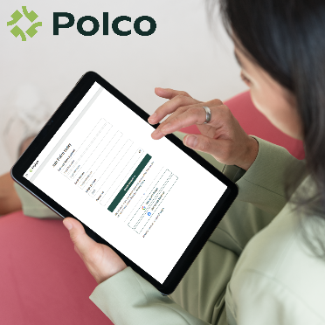

Sign-Up Reminder
Remind residents to sign-up and become part of your digital sounding board!

Just a reminder – (Community Name)’s [survey title] will go live in a few days!
To become a member of (Community Name)’s digital sounding board and get notified when the survey is available, follow this link and create a Polco profile: polco.us/n/res/signup
Thank you for helping build a better community!

