Pre-Survey Launch Templates

Initial Call for Sign-Ups
Announce the upcoming survey effort on social media and encourage your residents to become a part of your online panel.

Help us make (Community Name) a great place to live!
In just a few days, we will be launching the 2024 National Community Survey, in collaboration with Polco, (Community Name)’s online engagement platform. To become a member of our digital sounding board and gain early access to the upcoming survey, follow this link and register with (Community Name)’s profile: polco.us/n/res/signup
In addition to this effort, we plan to ask follow-up questions about important topics that impact our daily lives, including the local economy, safety, and strategic planning.
Sign up today to make your voice heard!
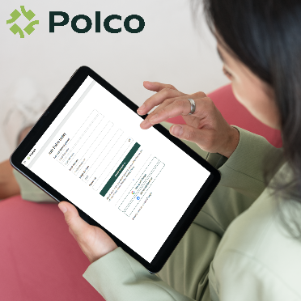

Sign-Up Reminder
Remind residents to sign-up and become part of your digital sounding board!

Just a reminder – (Community Name)’s 2024 National Community Survey will go live in a few days!
To become a member of (Community Name)’s digital sounding board and gain early access to the upcoming survey, follow this link and register for a Polco profile: polco.us/n/res/signup
Thank you for helping to create a better community for all!

