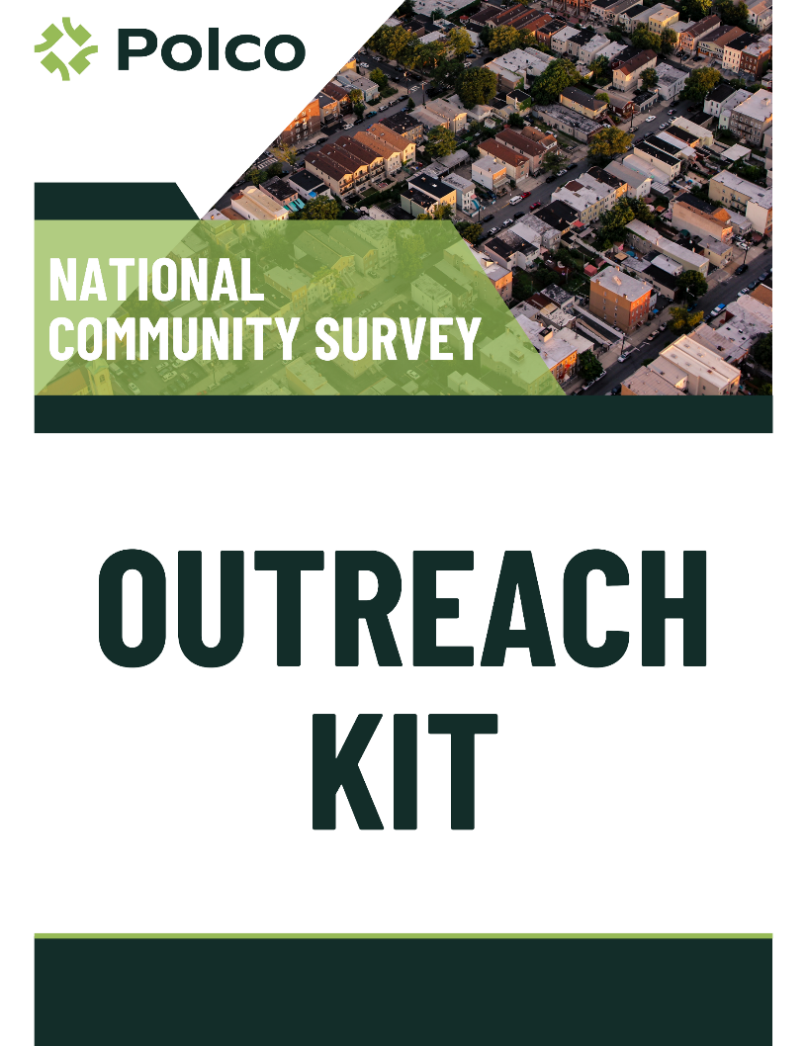

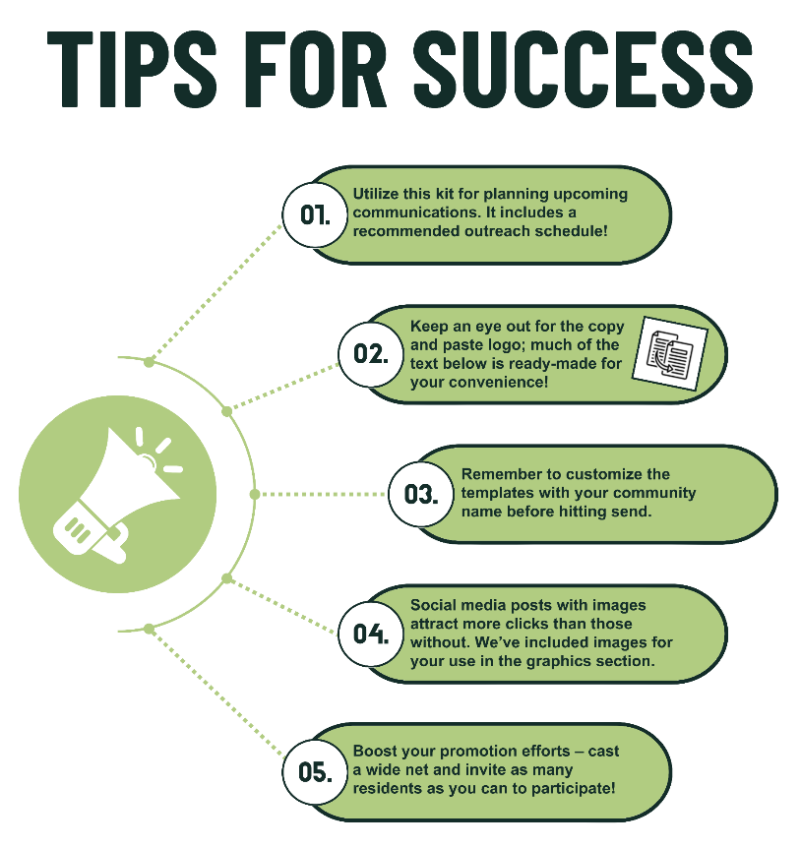

**Outreach Calendar**

**Pre-Survey Launch**

1. Initial Call for Sign-Ups
2. Sign-up Reminder
3. Sign-Up Business Cards (Template available in Outreach Kit zip file)

**Week 1: Survey Launch & Engage All Community Channels**

1. Initial Social Media Post
2. Press Release
3. Website
4. Initial Department Email
5. Newsletter Prep
6. Utility Bill Prep
7. Flyer (Template available in Outreach Kit zip file)

**Week 2: Engage Community Partners**

1. Initial Community Partners Outreach

**Week 3: Re-Engage All Community Channels**

1. Follow-Up Social Media Post
2. Follow-Up Department Email
3. Newsletter Release
4. Utility Bill Release

**Week 4: Re-Engage Community Partners**

1. Follow-Up Community Partners Outreach

**Ongoing: Continual Engagement Ideas**

* Events 
  1. Survey Business Cards (Template available in Outreach Kit zip file)
* Flyers
  1. Schools/Universities
  2. Libraries
  3. Municipal Buildings
  4. Parks
  5. Sporting Events
  6. Bus Stops
  7. Walkways
* Dedicated Public Computer
* Additional Social Media Posts
* Additional Graphics

**Pre-Survey Launch**

**Initial call for sign-ups**

*Announce the upcoming survey effort on social media and encourage your residents to become a part of your online panel.*



Help us make (Community Name) a great place to live!

In just a few days, we will be launching the 2024 National Community Survey, in collaboration with Polco, (Community Name)’s online engagement platform. To become a member of our digital sounding board and gain early access to the upcoming survey, follow this link and register with (Community Name)’s profile: [polco.us/n/res/signup](http://polco.us/n/res/signup)

In addition to this effort, we plan to ask follow-up questions about important topics that impact our daily lives, including the local economy, safety, and strategic planning.

Sign up today to make your voice heard!

**Follow-up: Pre-notification Sign-up**

*Remind residents to sign-up and become the first to receive the survey invitation!*

Just a reminder – (Community Name)’s 2024 National Community Survey will go live in a few days!

To become a member of (Community Name)’s digital sounding board and gain early access to the upcoming survey, follow this link and register for a Polco profile: <polco.us/n/res/signup>

Thank you for helping to create a better community for all!

**Week 1: Survey Launch &**

**Engage All Community Channels**

**Initial Social Media Post**

*Announce the start of the survey on all social media platforms.*

Hi neighbors! We invite you to take (Community Name)’s 2024 National Community Survey. Your feedback will help us make important plans for our community. Please complete the survey using the link below and encourage your family, friends, and neighbors to participate!

Thank you for helping our community move forward.

Take the Survey: [polco.us](https://polco.us/n/res/vote/_____________)/_______ (Short URL Link)

**Press Release**

*A sample press release to share with local media outlets announcing the launch of the survey.*

(City/Town/Village/etc.) OF (Community Name) SEEKS INPUT FROM RESIDENTS IN COMMUNITY-WIDE SURVEY

*The* (City/Town/Village/etc.) *launched The National Community Survey (The NCS) to gather resident input for strategic planning initiatives and to align goals around the community’s top priorities.*

(Community Name), [ST], [Date] – (Community Name) is excited to announce a resident survey to get input on government services and measure the quality of life in the community. The (City/Town/Village/etc.) plans to use the data in its upcoming strategic plan. The survey allows more people to participate in shaping the future of our community.

**[QUOTE FROM A LOCAL OFFICIAL ABOUT THE PURPOSE/VALUE OF THE SURVEY]**

*Example: “We are excited to receive more input for our strategic plan. The survey will help us get a baseline understanding of our services and allow us to measure our impact going forward,” said the City Manager.*

The National Community Survey (The NCS) was developed by the [National Research Center](https://info.polco.us/about-nrc?campaignid=12643533496&adgroupid=121566320393&adid=510707726150&utm_campaign=National+Research+Center&utm_source=adwords&utm_term=%2Bnational%20%2Bresearch%20%2Bcenter&utm_medium=ppc&hsa_ver=3&hsa_kw=%2Bnational%20%2Bresearch%20%2Bcenter&hsa_tgt=kwd-346653780394&hsa_acc=7131216017&hsa_cam=12643533496&hsa_ad=510707726150&hsa_mt=b&hsa_grp=121566320393&hsa_src=g&hsa_net=adwords&gclid=Cj0KCQiAqbyNBhC2ARIsALDwAsB45UJqjpnBQjz55Q5DNk-KwYvLuTqb0Gg0LKm4ptUE4G05PgnGX7IaAp0WEALw_wcB) (NRC) at [Polco](https://info.polco.us/). The survey captures opinions on the economy, mobility, community design, utilities, safety, natural environment, inclusivity, engagement, and other elements of (Community Name)'s overall livability. The results will show (Community Name)’s strengths, areas of improvement, and what matters most to residents. The (City/Town/Village/etc.) will also be able to see how its performance compares to other communities across the country.

To participate, residents should go to polco.us/)______ (short URL). Once they have answered the questions, residents will have the opportunity to provide their email address and ZIP code. This information allows the (City/Town/Village/etc.) to be sure they are hearing from each person only once and to confirm that respondents live in the community. Additionally, those who submit an email address will be subscribed to the (Community Name)’s profile with Polco, allowing for easy participation in future follow-up questions or engagement opportunities. Participants’ responses will always remain anonymous, and personal information will be securely stored on Polco. Participants’ individual data and votes are never shared.

**[QUOTE ENCOURAGING RESIDENTS TO TAKE THE SURVEY]**

*Example: “We strongly encourage all residents to take the survey. The more people who participate, the better data we will have to inform our plan,” said the City Manager.* “*This is an opportunity for everyone in the community to share their thoughts and shape the future of [City name].”*

For more information on this process, contact the (City/Town/Village/etc.) at [phone number/email/website]. The survey closes on [DATE].

**Website**

*Consider creating a landing page with information about Polco and The NCS.*

(Community Name) has partnered with Polco, a leader in the field of municipal online engagement and surveying, to issue the 2024 National Community Survey. All residents and community members can participate! Results will be compiled in a report by Polco which will be shared with the community upon completion.

**About Polco and The National Community Survey**

The National Community Survey (The NCS):

* Is endorsed by the International City/County Management Association (ICMA)
* Is used by more than 500 local government agencies around the country
* Offers benchmark database comparisons to other communities
* Uses a questionnaire developed by survey research and local government experts designed to provide feedback about community quality of life and quality of local government services
* Allows (Community Name) to track trends across 10 key facets of livability and hundreds of individual questions

To participate in this effort, please complete the survey here: polco.us/_______

If you have already responded to this year’s community survey, please don’t respond again, but help us spread the word! Please share this link with your neighbors and local networks in (Community Name).

For more information on this process, contact [phone number/email].

**Initial Department Email**

*Email to send to local departments (Parks and Recreation, Police/Sheriff, Public Works, Library, etc.).*

(Community Name) is excited to conduct the 2024 National Community Survey (The NCS) and gather feedback that will create a more connected and effective community. We believe this survey — paired with the use of the Polco engagement platform to conduct the survey — will be valuable in many ways:

* Residents can quickly and easily provide valuable feedback regarding (Community Name)’s efforts, creating an ongoing dialogue between residents and community leaders.
* Residents of (Community Name) can share their input and become involved in the decision-making process to move our community forward.
* After taking the survey, residents can stay informed on future polling or survey efforts and have an active voice in the community.
* Individual opinions and data are kept anonymous, ensuring residents’ privacy and security, while allowing staff to see broad demographic and geographic breakdowns of survey results.

We are asking for your help to reach as many residents of (Community Name) as possible by:

* Sharing our survey-related social media announcements on your own pages
* Emailing department employees and asking for their participation
* Posting the attached flyer in highly trafficked areas (e.g., reception areas, common spaces, break rooms, etc.)

Any and all efforts you take will help us to ensure that residents hear about this survey and have the opportunity to make their voices heard!

Thank you for helping to create a better community!

[name]

**[attach The NCS flyer]**

**Newsletter Prep**

*Release in newsletter as calendar permits.*

Your input is needed!

(Community Name) has launched the 2024 National Community Survey (The NCS) in collaboration with Polco, (Community Name)’s online engagement platform. Your participation in this survey will help leadership set priorities and develop better policies and programs to serve our community. All feedback will be anonymous, and any personal information will be securely stored by Polco.

Take the survey here: [polco.us](https://polco.us/n/res/vote/_____________)/_______ (Short URL Link) [insert QR code]

If you have already responded to this year’s community survey, please don’t respond again, but help us spread the word! Please share this link with your neighbors and local networks in (Community Name).

Thank you for your time and feedback!

**Utility Bill Prep**

*Release in utility bills as calendar permits.*

Your input is needed!

(Community Name) has launched the 2024 National Community Survey (The NCS) in collaboration with Polco, (Community Name)’s online engagement platform. Your participation in this survey will help leadership set priorities and develop better policies and programs to serve our community. All feedback will be anonymous, and any personal information will be securely stored by Polco.

Take the survey here: [polco.us](https://polco.us/n/res/vote/_____________)/_______ (Short URL Link) [insert QR code]

If you have already responded to this year’s community survey, please don’t respond again, but help us spread the word! Please share this link with your neighbors and local networks in (Community Name).

Thank you for your time and feedback!

**Week 2: Engage Community Partners**

**Initial Community Partners Outreach**

*Templated text to use for outreach to your community leaders. Some community leader examples include:*

* *Educational leaders (school boards, principals, university offices)*
* *Faith leaders (churches, synagogues, mosques, etc.)*
* *Business leaders (Chamber of Commerce, union/trade organizations)*
* *Social leaders (HOAs, PTAs, youth groups, sports organizations)*
* *Community leaders (YMCA, community centers, local nonprofits)*

(Community Name) is excited to launch the 2024 National Community Survey (The NCS) and gather feedback that will create a more connected and effective community. We believe this survey — paired with the use of the Polco Platform to conduct the survey — will be valuable in many ways:

* Residents can quickly and easily provide valuable feedback regarding (Community Name)’s efforts, creating an ongoing dialogue between residents and community leaders.

Residents of (Community Name) can share their input and become involved in the decision-making process to move our community forward. We are asking for your help to reach as many residents of (Community Name) as possible by:

* Sharing our survey-related social media material on your own pages
* Announcing this survey effort at your upcoming meetings, events, or gatherings
* Posting the attached flyer in highly trafficked areas (e.g., community bulletin boards, meeting agendas, upcoming public events, etc.)

Any and all efforts you take will help us to ensure that residents hear about this survey and have the opportunity to make their voices heard.

Thank you for helping to create a better community!

[name]

**[attach The NCS flyer]**

**Week 3: Re-Engage All   
Community Channels**

**Follow-up Social Media Post**

*Re-engage on social media.* *Additional Social Media Posts* *can be found below!*

What would you like (Community Name) to focus on? We value your opinions and want to know your thoughts for upcoming planning and budget decisions! We invite you to give your feedback in The National Community Survey. Thank you for sharing your voice.

Take the Survey: [polco.us](https://polco.us/n/res/vote/_____________)/_______ (Short URL Link)

**Follow-up Department Email**

*Email to send to local departments (Parks and Recreation, Police/Sheriff, Public Works, Library, etc.).*



The National Community Survey (The NCS) is live and residents are actively sharing their thoughts on (Community Name)! The survey will remain open for a few more weeks. Please continue to encourage residents to participate in The NCS by:

* Sharing our survey-related social media material on your own pages
* Encouraging department employees to participate and share with their own networks
* Posting the attached flyer in highly trafficked areas (e.g., reception areas, common spaces, break rooms, etc.)

We are hoping to reach as many residents as possible in this effort and continue to ask for their feedback in the future.

We appreciate your efforts in spreading the word as widely as possible!

[name]

**[attach The NCS flyer]**

**Week 4: Re-Engage Community Partners**

**Follow-up with Community Partners**

*Reminder email to send to community partners.*

The National Community Survey (The NCS) is live and residents are actively sharing their thoughts on (Community Name)! The survey will remain open for a few more weeks. Please continue to encourage fellow residents to participate in The NCS by:

* Sharing our survey-related social media material on your own pages
* Announcing this survey effort at your upcoming meetings, events, or gatherings
* Posting the attached flyer in highly trafficked areas (e.g., community bulletin boards, meeting agendas, upcoming public events, etc.)

We are hoping to reach as many residents as possible in this effort and continue to ask for their feedback in the future.

We appreciate your efforts in encouraging your local networks to participate!

[name]

**[attach The NCS flyer]**

**Continual Engagement Opportunities**

**Events**

Templates for business cards are located in the Promotional Kit zip file. Consider sharing business cards with the survey URL or general link to subscribe to your community’s Polco profile at:

* Farmer’s markets
* Parades
* Community festivals
* Holiday events
* Sporting events

**Flyers in Facilities**

Template for The NCS flyer is located in the Promotional Kit zip file. Some suggested locations to post these flyers include:

* Schools/Universities
* Libraries
* Municipal buildings
* Parks
* Sporting events
* Bus stops
* Walkways

**Dedicated Public Computer Location**

Consider providing a public location for residents to take the survey in the following locations:

* Library
* Municipal buildings
* Community centers
* Tablets at public events

**Additional Social Media Posts**

Join your fellow residents in helping make our community a great place to live! (Community Name) has launched The National Community Survey to help us better serve residents like you.

Take the Survey: polco.us/_______ (Short URL Link)

--------------------------------------------------------------------------------

You know best what life is like in (Community Name), so we want to hear from you! Please take The National Community Survey today and help inform future plans.

Take the Survey: polco.us/_______ (Short URL Link)

--------------------------------------------------------------------------------

Have a say in what (Community Name) does next! Your feedback on The National Community Survey will help inform how we move forward.

Take the Survey here: polco.us/_______ (Short URL Link)

--------------------------------------------------------------------------------

How would you rate safety services in (Community Name)? Let us know this and more on The National Community Survey today! Don’t wait - this survey closes soon!

Take the Survey: polco.us/_______ (Short URL Link)

--------------------------------------------------------------------------------

How would you rate the economic health of (Community Name)? Please take a few moments to share your feedback on The National Community Survey. We’ll be using your input to help make upcoming budget decisions.

Take the Survey: polco.us/_______ (Short URL Link)

--------------------------------------------------------------------------------

Housing, safety, development, government services - everyone has a reason to participate in The 2024 National Community Survey!

Visit polco.us/_______ (Short URL Link) before [close date] to have your say today!

--------------------------------------------------------------------------------

The 2024 National Community Survey is live! Share your thoughts on the future of our community before [close date] at polco.us/_______ (Short URL Link)

**Additional Graphics**

*Social media posts that include colorful images get more clicks than posts that don’t. Feel free to choose an illustration provided by Polco or use your own. Pictures of your community (like skylines or popular downtown areas) are great! You can even tag partners in pictures to remind them to retweet or share. Use images with little to no text.*

