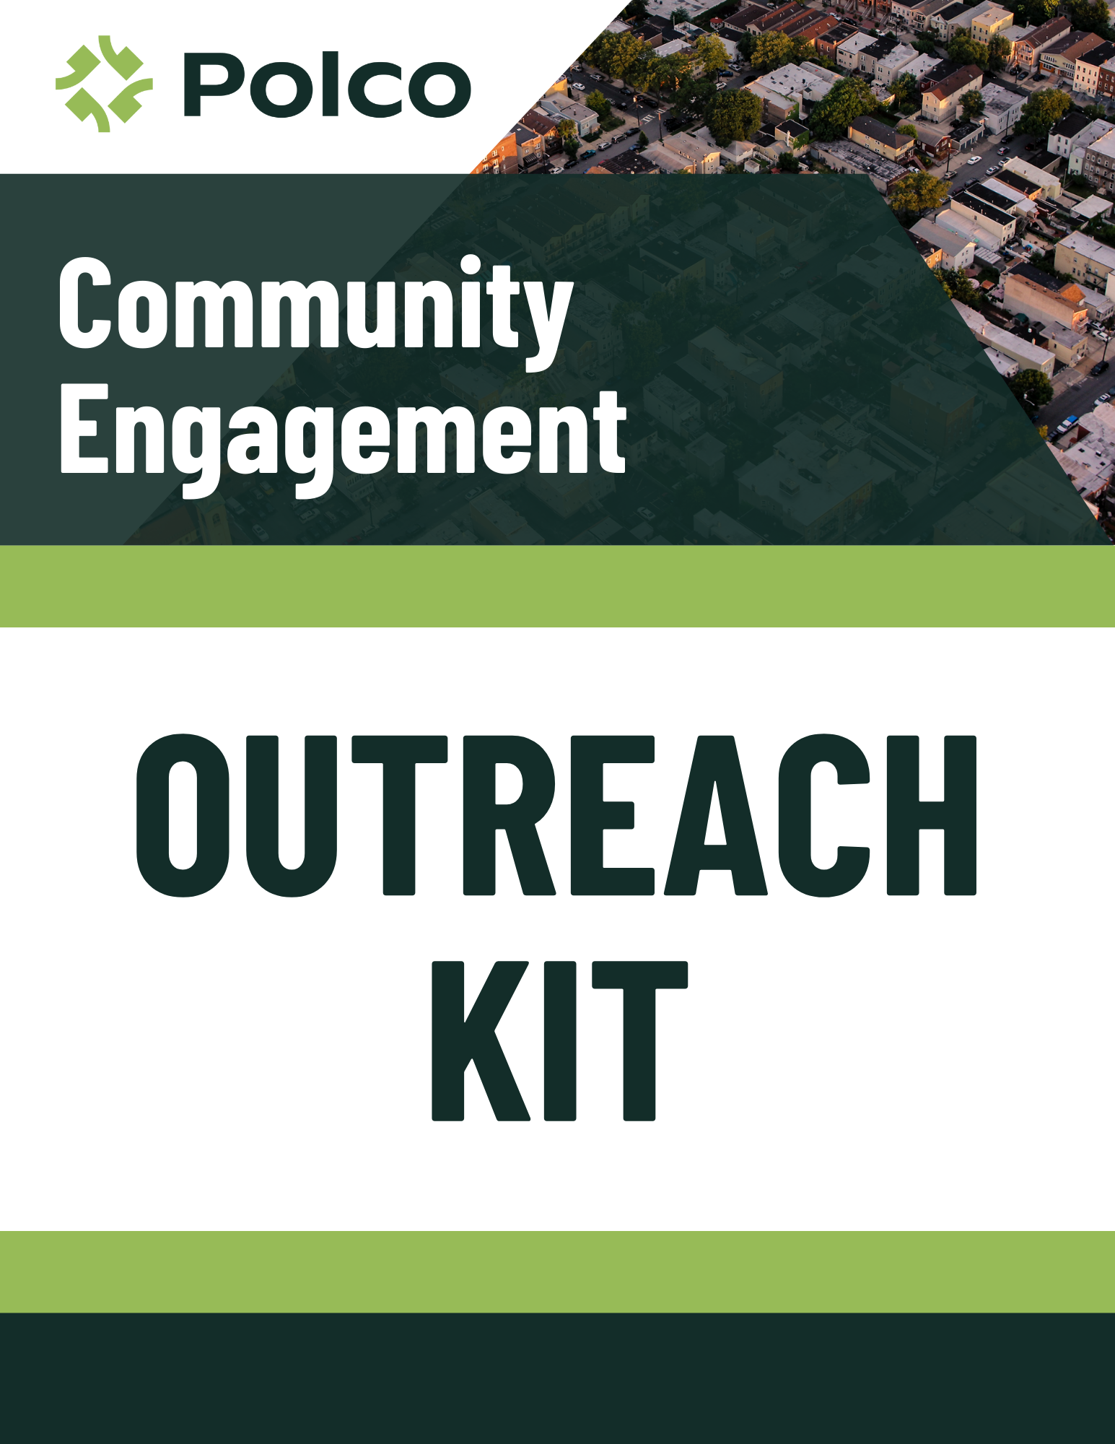
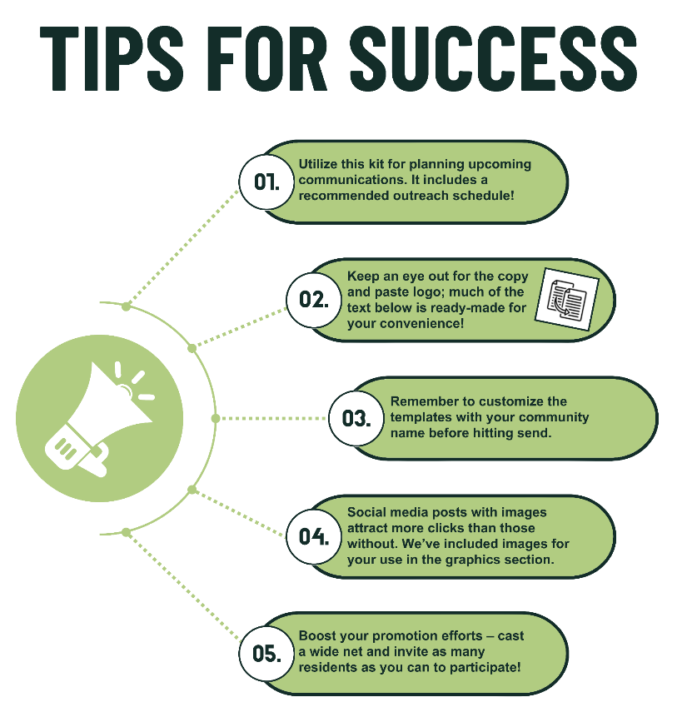

Outreach Calendar and Resources
Pre-Survey Launch 3
Initial Call for Sign-Ups 3
Sign-Up Reminder 4
Pre-Survey Business Cards Template attached separately
Week 1: Survey Launch 5
Email to Polco Subscribers 5
Initial Social Media Post 6
Press Release 7
Website Announcement 8
Newsletter Message 9
Utility Bill Inserts 9
Survey Flyer Template attached separately
Week 2: Engage Community Partners 10
Email to Municipal Departments 10
Email to Community Partners 11
Week 3: Community Reminders 12
Follow-Up Social Media Post 12
Week 4: Final Reminders 13
Reminder to Community Partners and Departments 13
Final Social Media Post 14
Appendix: Additional Engagement Resources 15
Engagement Opportunities 15
Survey Business Cards Template attached separately
Additional Social Media Post Templates 16
Additional Graphics 17

Pre-Survey Launch

Initial Call for Sign-Ups
Announce the upcoming survey effort on social media and encourage your residents to become a part of your online panel.

Help us make (Community Name) a great place to live!
In just a few days, we will be launching the [survey title] survey on Polco, (Community Name)’s online civic engagement platform. To become a member of our digital sounding board and get notified when this survey is available, follow this link and register for a Polco profile: polco.us/n/res/signup
In addition to this survey, we’ll use Polco to ask follow-up questions about important topics that impact our entire community, including the local economy, safety, and strategic planning.
Sign up today to join the conversation!
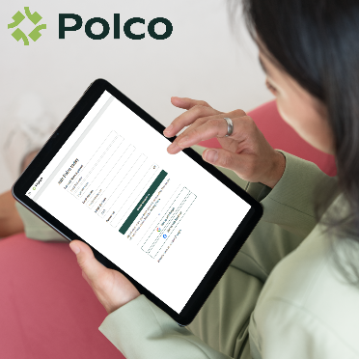

Sign-Up Reminder
Remind residents to sign-up and become part of your digital sounding board!
Just a reminder – (Community Name)’s [survey title] will go live in a few days!
To become a member of (Community Name)’s digital sounding board and get notified when the survey is available, follow this link and create a Polco profile: polco.us/n/res/signup
Thank you for helping build a better community!

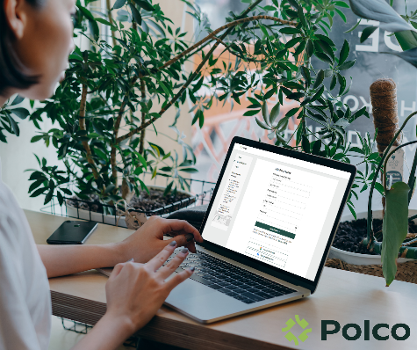

Week 1: Survey Launch

Email to Polco Subscribers
Use the built-in notification system to let your Polco subscribers know the survey is live.
We need your input to build a stronger community! Please take a few minutes to complete the [survey title] survey today. Your feedback on [survey topic] will help us [survey goal]. These results will help us ensure that our policies and programs align with our residents’ highest priorities, allowing us to make more informed decisions moving forward.
You’re receiving this email because you’ve subscribed to follow the (City/Town/Village/etc.) of (Community Name) on Polco, our civic engagement platform that brings residents’ voices into local government decision-making processes. We appreciate your time and participation in these important community matters! Your responses are always confidential, and your personal data or identifying information are never shared.
After you’ve responded to this survey, please help us spread the word! Share this link with your neighbors and local networks within (Community Name) to encourage widespread participation across the community. Thank you for your time and invaluable feedback!

Initial Social Media Post
Announce the start of the survey on all social media platforms.
Hi neighbors! We invite you to take (Community Name)’s [survey title]. Your feedback will help us make important plans for our community. Please complete the survey using the link below and encourage your family, friends, and neighbors in (Community Name) to participate!
Thank you for helping our community move forward.
Take the survey here: polco.us/_______ (Short URL Link)

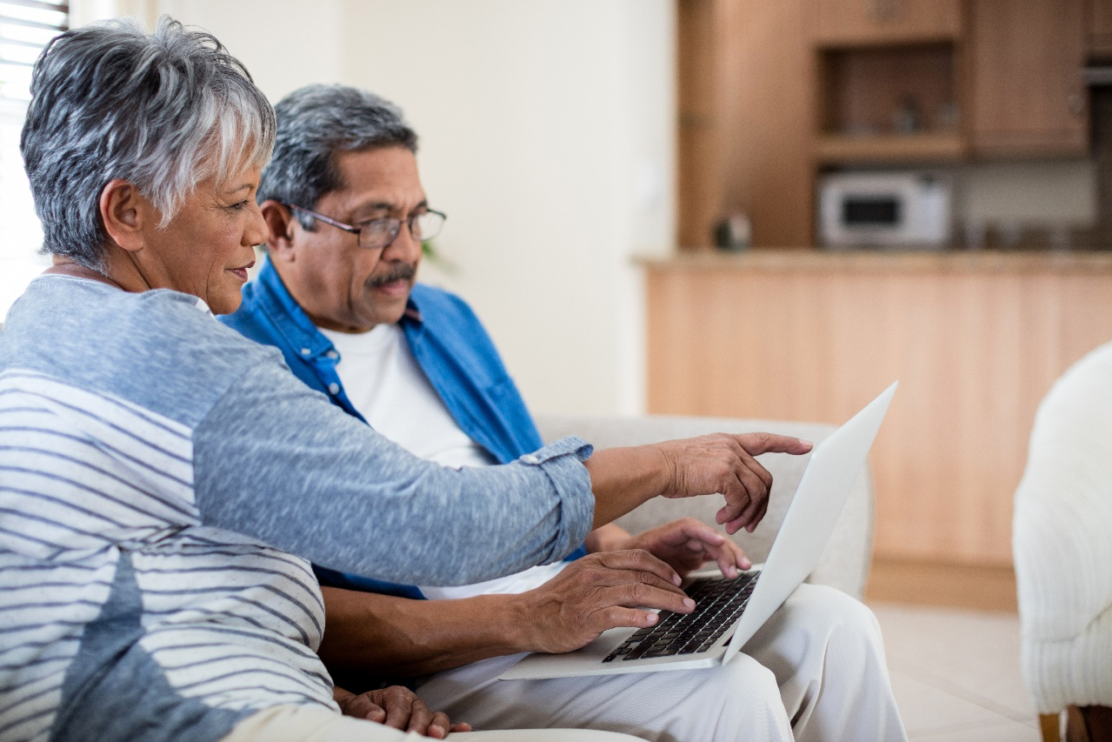

Press Release
Share with local media outlets to announce the launch of the survey.
(City/Town/Village/etc.) OF (Community Name) SEEKS INPUT FROM RESIDENTS IN COMMUNITY-WIDE SURVEY
The (City/Town/Village/etc.) launched the [survey title] to gather resident input for [survey goals].
(Community Name), [ST], [Date] – (Community Name) is excited to announce a resident survey to explore resident perceptions and preferences regarding [topic area]. Public input from this survey will help the (City/Town/Village/etc.) develop better policies, initiatives, and community programs. The survey allows more people to participate in shaping the future of (Community Name).
[QUOTE FROM A GOV OFFICIAL OR STAFF MEMBER ABOUT THE
PURPOSE/VALUE OF THE SURVEY]
Example: “We are excited to receive more input for our upcoming parks redesign project. The survey will help us get a baseline understanding of our current offerings and allow us to measure what the community cares about most moving forward,” said the Director of Parks and Recreation.
To participate, residents should visit polco.us/)______ (short URL). The survey closes on [DATE]. Participants’ responses will always remain anonymous, and personal information will be securely stored on Polco. Residents’ individual data and votes are never shared. For more information on this process, contact the (City/Town/Village/etc.) at [phone number/email/website].
[QUOTE ENCOURAGING RESIDENTS TO TAKE THE SURVEY]
Example: “We strongly encourage all residents to take the survey. The more people who participate, the better data we will have to inform our plan,” said the Director of Parks and Recreation. “This is an opportunity for everyone in the community to share their thoughts and shape the future of [City name].”
The (City/Town/Village/etc.) plans to continue engagement efforts on Polco in the coming weeks and months around this and other topics, based on the outcome of this survey. Residents are encouraged to create an account with Polco to continue the conversation and share input with the (City/Town/Village/etc.) in future surveys.
About Polco: Polco brings people and data together to help build stronger, healthier communities. With award-winning community engagement tools and services, Polco allows leaders to engage residents around their most important topics, align goals, and strengthen public trust. Polco is committed to a strict privacy policy, designed to keep participants’ responses confidential and protect personal data. Learn more at info.polco.us.

Website Announcement
Consider creating a blog post or website banner/modal that directs visitors to your active survey.
(Community Name) needs your input! Please take a few moments to complete the [survey title]. All residents and community members are encouraged to participate! Results from this survey effort will used to [survey goals].
If you’ve already taken this survey, help us spread the word! Please share this link with your neighbors and local networks in (Community Name). For more information on this survey questionnaire and/or process, contact [phone number/email].
About Polco
Polco brings people and data together to help build stronger, healthier communities. With award-winning community engagement tools and services, Polco allows leaders to engage residents around their most important topics, align goals, and strengthen public trust. Polco is committed to a strict privacy policy, designed to keep participants’ responses confidential and protect personal data. Learn more at info.polco.us.


Newsletter Message
Release in newsletter if calendar permits.
Your input is needed!
(Community Name) has launched the [survey title] on Polco, (Community Name)’s online engagement platform. Please take a few minutes to share your feedback! Your participation in this survey will help leadership set priorities and develop better policies and programs to serve our community. All responses will be anonymous, and any personal information will be securely stored by Polco.
Take the survey here: polco.us/_______ (Short URL Link) [insert QR code]
If you have already responded to this survey, please don’t respond again, but help us spread the word! Please share this link with your neighbors and local networks in (Community Name).
Thank you for your time and feedback!

Utility Bill Inserts
Include in utility bills if calendar permits.
Your input is needed!
(Community Name) has launched the [survey title] on Polco, (Community Name)’s online engagement platform. Please take a few minutes to share your feedback! Your participation in this survey will help leadership set priorities and develop better policies and programs to serve our community. All responses will be anonymous, and any personal information will be securely stored by Polco.
Take the survey here: polco.us/_______ (Short URL Link) [insert QR code]
If you have already responded to this survey, please don’t respond again, but help us spread the word! Please share this link with your neighbors and local networks in (Community Name).
Thank you for your time and feedback!

Week 2: Engage Community Partners

Email to Municipal Departments
Invite other internal municipal departments (e.g., Parks and Recreation, Police/Sheriff, Public Works, Library, etc.) to share the survey with their visitors and online followers.
(Department Name) is excited to launch the [survey title] to gather residents’ feedback on [topic area]. We believe this survey—paired with the use of the Polco engagement platform to conduct the survey—will help us not only to [survey goals] but also to create a more connected community moving forward.
We are asking for your help to reach as many residents of (Community Name) as possible by:
- Sharing our survey-related social media announcements on your own pages
- Asking internal department employees for their participation
- Posting the attached flyer in highly trafficked areas (e.g., reception areas, common spaces, break rooms, bulletin boards, etc.)
Your support will not only increase the reach of this survey but will also facilitate much-needed connections and conversations between our residents and local leadership. This survey effort lays the groundwork for stronger community-wide engagement and collaboration.
The Polco community engagement platform is a valuable resource available to all departments in the (City/Town/Village/etc.) to gather feedback from residents on various topics. In this survey effort, respondents can sign up to receive notifications about future polls or surveys from the (City/Town/Village/etc.), allowing residents to maintain an active voice in community matters. Additionally, if your department uses Polco for future feedback efforts, you can tap into this existing panel of engaged residents. The platform saves time on outreach, guarantees anonymity for respondents, and provides internal staff with aggregated demographic and geographic data for in-depth analysis. For all these reasons, we invite you to consider using Polco for your own department’s engagement needs! Please don’t hesitate to reach out if you’d like to learn more about using Polco or if we can similarly help promote your team’s initiatives in the community.
Thank you for working to build a better community!
[name]
[attach the survey flyer]

Email to Community Partners
Connect with your fellow community leaders to help publicize the survey and reach more participants. Some community leader examples include:
- Educational leaders (school boards, principals, university offices)
- Faith leaders (churches, synagogues, mosques, etc.)
- Business leaders (Chamber of Commerce, union/trade organizations)
- Social leaders (HOAs, PTAs, youth groups, sports organizations)
- Community leaders (YMCA, community centers, local nonprofits)
We are excited to launch the [survey title] and gather residents’ feedback on [topic area]. This survey creates space for community members to anonymously provide input on (Community Name)’s efforts, actively influencing (City/Town/Village/etc.) decisions and shaping our community’s future.
We know our community is comprised of individuals with vastly different experiences and viewpoints. We also know that despite our best efforts, our own municipal outreach methods won’t reach every corner of our community. To serve all (Community Name) residents fairly and effectively, we need to hear from as many diverse perspectives as possible.
For that reason, we’re asking for your help! We kindly request that you promote this survey with your visitors, patrons, and online networks by:
- Sharing our survey-related social media material on your own platforms
- Announcing this survey effort at your upcoming meetings, events, or gatherings
- Posting the attached flyer in highly trafficked areas (e.g., community bulletin boards, meeting agendas, upcoming public events, etc.)
Please help us ensure that all residents have the chance to make their voices heard! Polco’s platform guarantees anonymity for respondents, so candid and honest participation is encouraged. Your support in this effort will not only increase the reach of this survey but will also support an ongoing dialogue between residents and local leadership.
Thank you for helping to create a more connected and inclusive community!
[name]
[attach survey flyer]

Week 3: Community Reminders

Follow-Up Social Media Post
Re-engage on social media. Additional Social Media Post Templates can be found below!
What would you like (Community Name) to focus on? We value your opinions and want to know your top priorities! Take the [survey title] to help inform our future plans. The survey closes soon, so please share your thoughts today.
Take the survey here: polco.us/_______ (Short URL Link)



Week 4: Final Reminders

Reminder to Community Partners and Departments
Send this reminder email to community partners (e.g., school or university leaders, faith leaders, Chamber of Commerce, HOAs, PTAs, community centers, local nonprofits) and/or internal departments (e.g., Parks and Recreation, Police/Sheriff, Public Works, Library, etc.).
The [survey title] is live, and residents are actively sharing their thoughts on (Community Name)! The survey will remain open for a few more weeks. Please continue to encourage community participation by:
- Sharing our survey-related social media material on your own pages
- Announcing this survey effort at your upcoming meetings, events, or gatherings
- Posting the attached flyer in highly trafficked areas (e.g., community bulletin boards, meeting agendas, upcoming public events, etc.)
We are hoping to reach as many residents as possible in this effort and continue to ask for their feedback in the future.
We appreciate your efforts in encouraging your local networks to participate!
[name]
[attach survey flyer]

Final Social Media Post
Issue a final social media post, emphasizing the survey deadline and urgency. Additional Social Media Posts can be found below!
Don’t wait! Take the [survey title] today before it closes. We need a few minutes of your time to make the best decisions possible for our community. Visit polco.us/_______ (Short URL Link) now!


Appendix:
Additional Engagement Resources

Engagement Opportunities
Events
Templates for business cards are located in the Promotional Kit zip file. Consider sharing either the survey or pre-notification business cards at:

- Municipal building service or information desks
- Public meetings
- Neighborhood associations
- Community/rec center front desks
- Community festivals
- Farmer’s markets
- Holiday events
- Sporting events
- Parades
- Public transportation

Flyers in Facilities
The template for a survey flyer is located in the Promotional Kit zip file. Some suggested locations to post these flyers include:
- Schools/Universities
- Libraries and community centers
- Municipal buildings
- Parks
- Sporting events
- Bus stops
- Walkways

Dedicated Public Computer
Consider providing a public location and shared computer for residents to take the survey. Some potential locations:
- Library
- Municipal buildings
- Community centers
- Tablets at public events

Additional Social Media Post Templates
Join your fellow residents in helping make our community a great place to live! (Community Name) has launched the [survey title] to help us better serve residents like you.

Share your input today: polco.us/_______ (Short URL Link)

--------------------------------------------------------------------------------

You know best what life is like in (Community Name), so we want to hear from you! Please take the [survey title] today and help inform future plans.

Take the survey: polco.us/_______ (Short URL Link)

--------------------------------------------------------------------------------

Have a say in what (Community Name) does next! Your feedback on the [survey title] will help inform how our community moves forward.

Take the survey now: polco.us/_______ (Short URL Link)

--------------------------------------------------------------------------------

How would you rate safety in (Community Name)? Let us know this and more on the [survey title]! Don’t wait - this survey closes soon!

Share your feedback: polco.us/_______ (Short URL Link)

--------------------------------------------------------------------------------

How would you rate the economic health of (Community Name)? Please take a few moments to share your feedback in the [survey title]. We’ll be using your input to help make upcoming budget decisions.

Provide your input here: polco.us/_______ (Short URL Link)

--------------------------------------------------------------------------------

Housing, safety, development, government services - everyone has a reason to participate in the [survey title]! Help us identify top priorities for our community today.

Visit polco.us/_______ (Short URL Link) before [close date] to have your say today!

--------------------------------------------------------------------------------

The [survey title] is live! Share your thoughts on our community’s [topic area] offerings and services before [close date] at polco.us/_______ (Short URL Link)

Additional Graphics
Social media posts that include colorful images get more clicks than those without. Feel free to choose an illustration provided by Polco or use your own. Pictures of your community (like skylines or popular downtown areas) are great! You can even tag partners in pictures to remind them to retweet or share. Use images with little to no text.





















