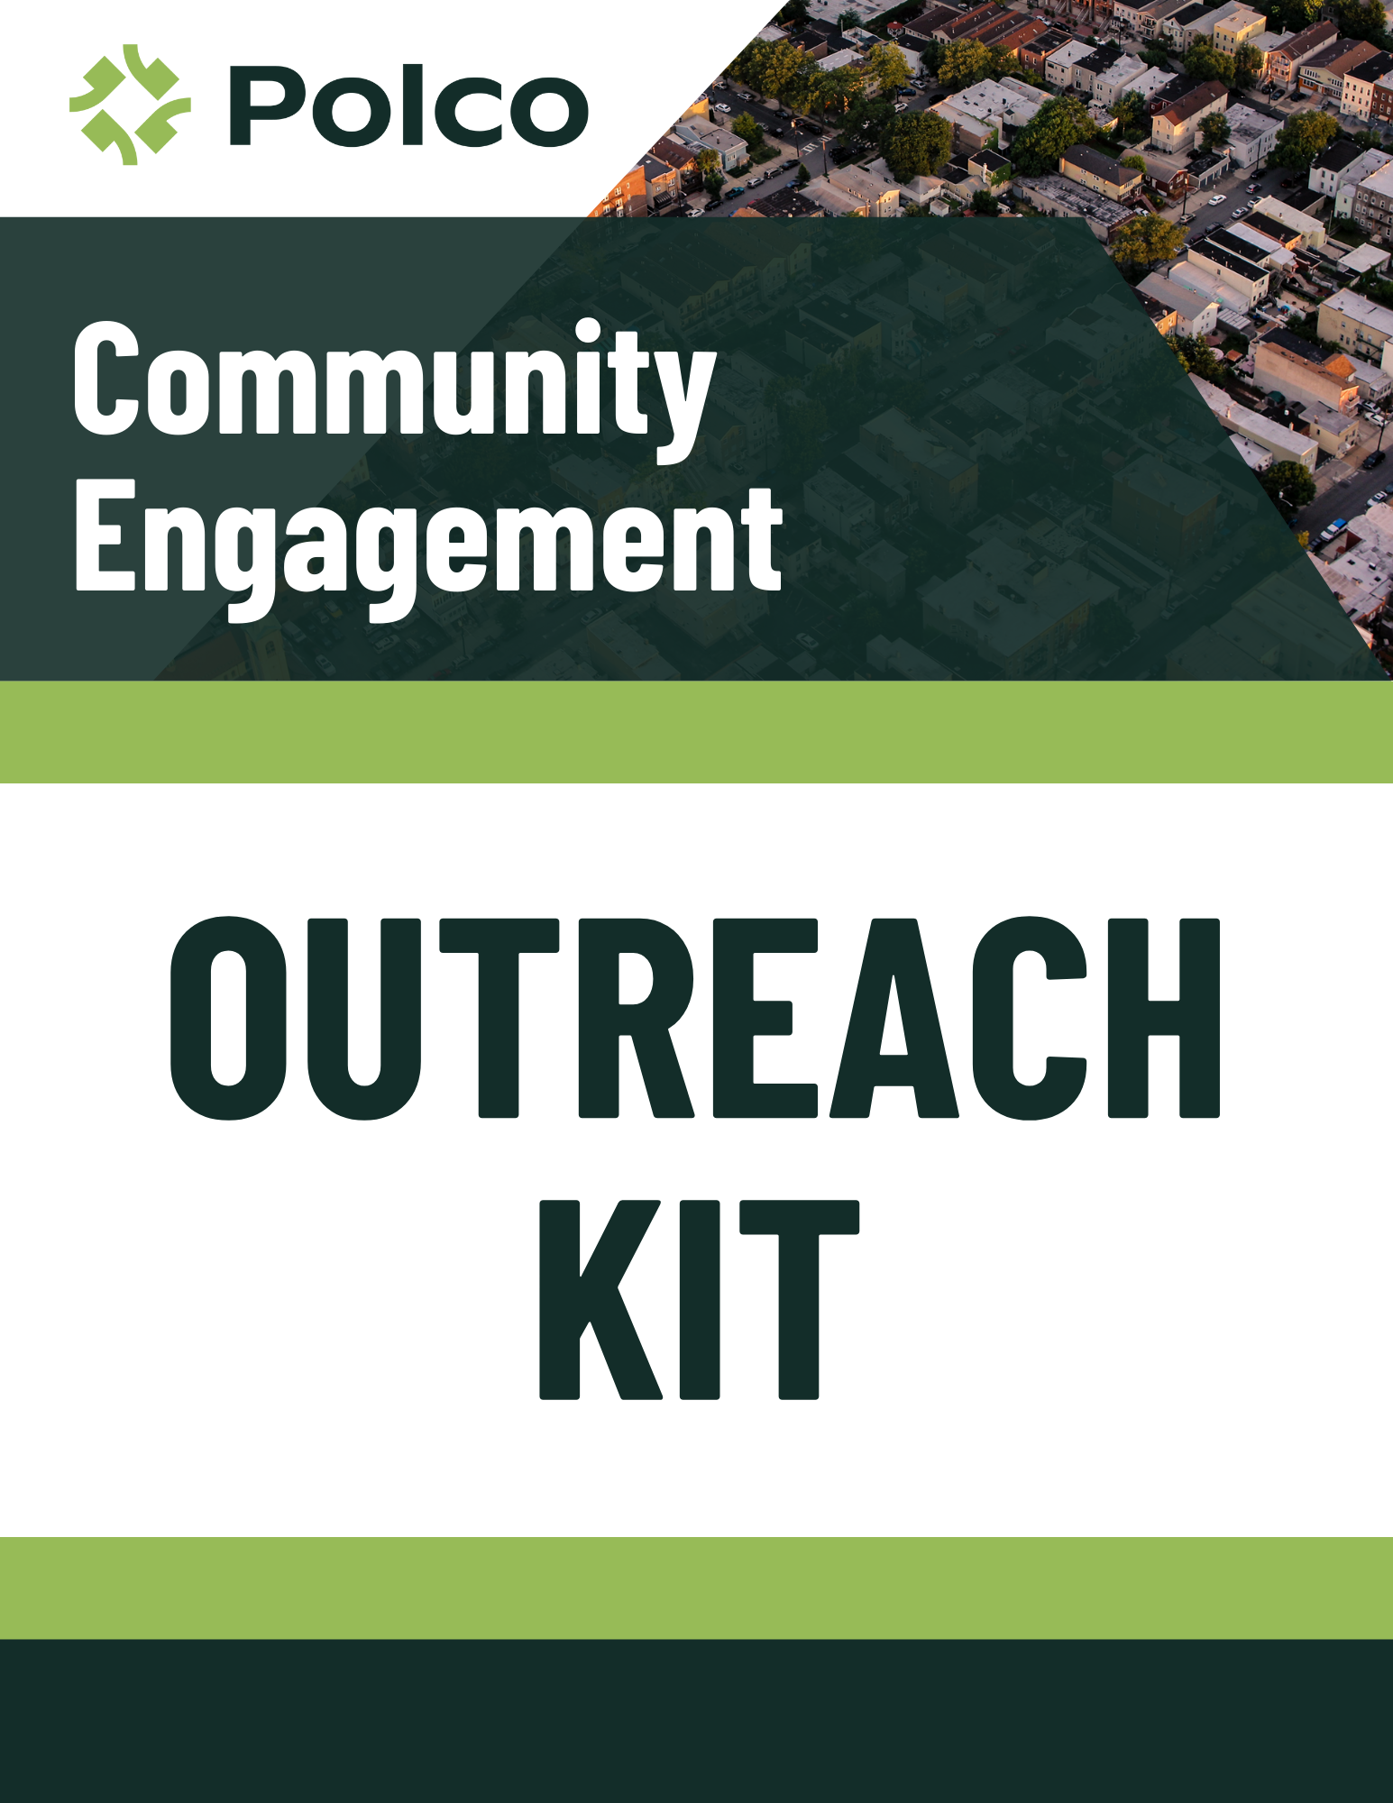

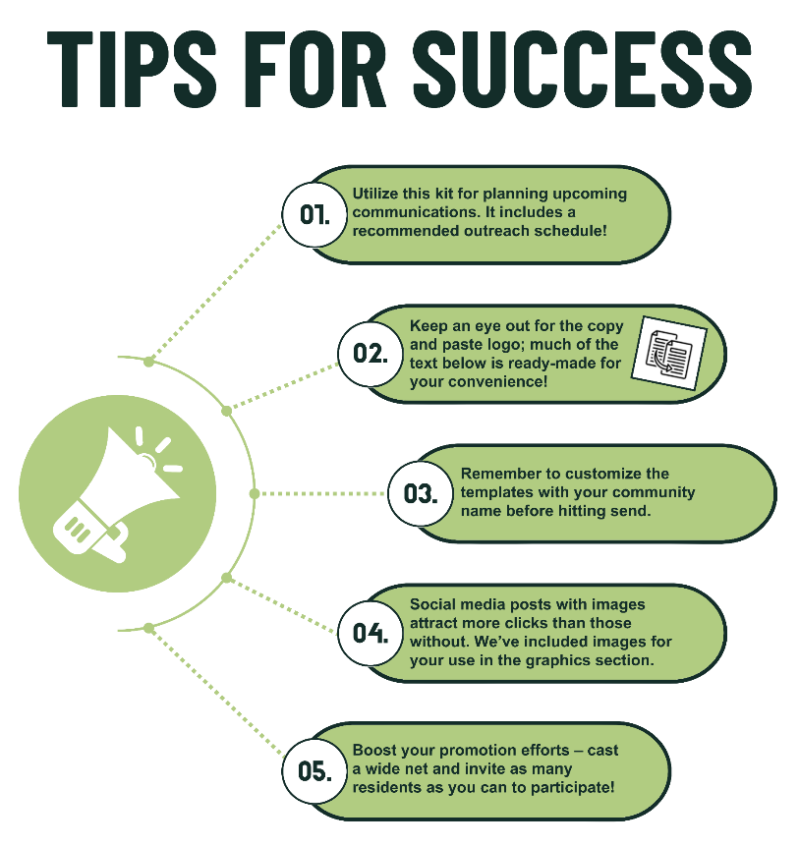

Using This Outreach Kit

This outreach kit is designed to make publicizing your Community Assessment Survey for Older Adults (CASOA®) as easy as possible! Our goal is to simplify your survey-related communications and ensure some level of consistency in this large-scale project. To that end, this kit includes suggested text and timing for various types of communications, ready for copy/pasting.

If you have any questions or suggestions regarding this kit, please don’t hesitate to reach out! We’d love to hear how we might better support you in your survey-related communications.

Customization

*Messaging*

You’re encouraged to adjust any of the messaging within this kit to better suit your unique voice and audience. You know best what will resonate with your residents! These templates provide guidance on what details to include during different times throughout the survey, but you can certainly modify the language as you like.

Additionally, if you have other communication channels not addressed here, please use them! Feel free to repurpose text throughout as needed to fit different communication modes, such as reworking an email template into a social media post. However, be sure to stay within the correct project phases/weeks! **Do not share any survey URLs before the open participation survey launches on [OP launch date].** If you have any questions about timing, please contact Polco to double-check.

*Highlighted Text*

Throughout the kit, you’ll see a few items highlighted in yellow (often names or contact info specific to your organization), which you will need to manually update before publishing.

*Images*

Along with the templated text, we recommend using images when appropriate to grab readers’ attention. You’re welcome to use any of our stock photos (located in the Appendix of this document) or choose your own images from your community. Try to select diverse photos and graphics related to the survey and its target participants (adults age [minimum age]+).

Thank you for your help in making this survey a success!

Outreach Calendar



Outreach Templates and Resources

Pre-Survey Launch 5

Initial Announcement 5

Sign-Up Reminder 6

Week 1: Random Sample Survey Launch 7

Website Announcement 7

Press Release 8

Social Media Post 9

Week 2: Expanded Publicity 10

Newsletter Message: Random Sample Survey 10

Social Media Post 11

Week 3: Continued Engagement 12

Social Media Post 12

Week 4: Open Participation Survey Preparation 13

Social Media Post 13

Open Participation Survey Flyer 13

Newsletter Message: Open Participation Survey 14

Utility Bill Inserts 14

Week 5: Open Participation Survey Launch 15

Website Announcement 15

Email to Existing Distribution List 16

Press Release 17

Social Media Posts 18

Open Participation Survey Flyer 19

Email to Community Partners 19

Week 6: Final Reminders 21

Reminder Email to Distribution List 21

Reminder Email to Community Partners 22

Reminder Social Media Posts 23

Appendix: Additional Engagement Resources 24

Additional Social Media Post Templates 24

Additional Graphics 26

Pre-Survey Launch

Initial Announcement

*Announce the upcoming survey effort on social media, via email lists, or other communication channels. Prepare residents for potentially receiving mailed invitations and encourage residents to become part of your online panel.*

Help us make [State Name/City Name/County Name/our community] a great place to live and age with dignity!

On [random sample launch date], we will be launching the 2024 Community Assessment Survey for Older Adults. Randomly selected households will begin receiving mailed survey invitations around that time. If you receive an invite, please follow the instructions to provide your feedback!

Residents who are not randomly selected will have the opportunity to participate in a few weeks, when the survey opens to all community members age [minimum age]+. Sign up now to receive an email notification when this survey is available on Polco, our secure civic engagement platform! Simply click the link below, select “Follow” next to [Name of Polco profile hosting the survey], and set up a Polco account: https://polco.us/n/res/profile/[SLUG]

Thank you in advance for joining the conversation!

Sign-Up Reminder

*Remind residents to sign-up and become part of your digital sounding board!*

Just a reminder – the 2024 Community Assessment Survey for Older Adults will go live soon! Public input from this survey will help inform the development of policies, initiatives, and community programs serving seniors throughout [State Name/City Name/County Name/our community].

Randomly selected households will receive mailed invitations over the next few weeks. All residents age [minimum age]+ will be encouraged to participate later on, so stay tuned! To get notified by email when the survey is available:

* Click this link: https://polco.us/n/res/profile/[SLUG]
* Select “Follow” next to the [Name of Polco profile hosting the survey]
* Set up your secure Polco account

We look forward to hearing your feedback!

Week 1: Random Sample Survey Launch

Website Announcement

*Creating a landing page or blog post to share information about the survey and Polco.*

[State Name/City Name/County Name/AAA] is conducting the 2024 Community Assessment Survey for Older Adults in partnership with Polco, a leader in civic engagement and survey research. Results from this survey effort will help inform the development of policies, initiatives, and community programs serving seniors throughout the [state/city/county/area].

Randomly selected households will receive mailed survey invitations over the next few weeks. If you receive an invitation, please follow the instructions to share your input.

All residents in [State Name/City Name/County Name/our community] age [minimum age]+ will be invited to participate when the larger survey opens on [OP launch date]. Watch for additional announcements over the next few weeks! You can also click the link below to “Follow” the [Name of Polco profile hosting the survey], create a Polco account, and receive an email notification when the survey is live: https://polco.us/n/res/profile/[SLUG]

For more information on this survey questionnaire and/or process, contact [City/County/AAA phone number/email].

**About Polco**

Polco brings the voice of everyday residents to their community leaders with award-winning community engagement services, online polls, and survey research. With Polco, leaders around the nation can make better-informed decisions for their communities with accurate and reliable feedback. Polco is committed to a strict privacy policy, designed to keep participants’ responses confidential and protect personal data. Learn more at info.polco.us.

Press Release

*Share with local media outlets to announce the launch of the survey.*

**[State Name/City Name/County Name/AAA]** **SEEKS RESIDENT INPUT ON SENIOR SERVICES AND NEEDS**

[Community Name], [ST], [Date] – [State Name/City Name/County Name/AAA] is excited to announce the launch of a comprehensive needs assessment survey of older adults.

Postcards inviting residents age [minimum age] and older to take the Community Assessment Survey for Older Adults were mailed to over 158,000 randomly selected households across [State Name/City Name/County Name/our community]. A paper survey packet with postage-paid return envelope will soon follow. Households that receive these mailings are asked to follow the enclosed instructions and complete the survey.

This questionnaire is available online in English, Spanish, Simplified Chinese, Traditional Chinese, Korean, Arabic, Vietnamese, Hindi, and Tagalog. All eligible residents will have the opportunity to complete the survey beginning on [OP launch date].

**[QUOTE ENCOURAGING RESIDENTS TO TAKE THE SURVEY]**

*Example: “We strongly encourage all eligible residents to take the survey. The more people who participate, the better data we will have to inform our plan,” said [name/role].* “*This is an opportunity for everyone to share their thoughts and shape the future of aging in [State/City/County].”*

[State Name/City Name/County Name/AAA] is conducting this survey in partnership with AAAs throughout the state and Polco, a trusted research firm and civic engagement platform. Developed by [National Research Center](https://info.polco.us/about-nrc?campaignid=12643533496&adgroupid=121566320393&adid=510707726150&utm_campaign=National+Research+Center&utm_source=adwords&utm_term=%2Bnational%20%2Bresearch%20%2Bcenter&utm_medium=ppc&hsa_ver=3&hsa_kw=%2Bnational%20%2Bresearch%20%2Bcenter&hsa_tgt=kwd-346653780394&hsa_acc=7131216017&hsa_cam=12643533496&hsa_ad=510707726150&hsa_mt=b&hsa_grp=121566320393&hsa_src=g&hsa_net=adwords&gclid=Cj0KCQiAqbyNBhC2ARIsALDwAsB45UJqjpnBQjz55Q5DNk-KwYvLuTqb0Gg0LKm4ptUE4G05PgnGX7IaAp0WEALw_wcB) at [Polco](https://info.polco.us/), the questionnaire covers different factors impacting older adults’ quality of life, including local employment and volunteer opportunities, housing, accessibility, mobility, and physical and mental health.

Survey results will help identify the greatest challenges and needs for older adults throughout the [state/city/county/area]. This public input will support the development of policies, initiatives, and community programs serving adults [minimum age] and older.

**[QUOTE FROM A GOV OFFICIAL OR STAFF MEMBER ABOUT THE   
PURPOSE/VALUE OF THE SURVEY]**

*Example: “We are excited to receive more input to inform our statewide Master Plan on Aging,” said [name/role]. “The survey will help us understand the biggest challenges facing older individuals in our community, and we can use that information to make sure our plans address residents’ most pressing needs.”*

Participants’ responses will be kept confidential, and personal information will be securely stored on Polco. Residents’ individual data are never shared.

For more information on this survey, contact the [City/County/AAA] at [phone number/email/website].

**About Polco:** Polco brings the voice of everyday residents to their community leaders with award-winning community engagement services, online polls, and survey research. With Polco, leaders around the nation can make better-informed decisions for their communities with accurate and reliable feedback. Polco is committed to a strict privacy policy, designed to keep participants’ responses confidential and protect personal data. Learn more at info.polco.us.

Social Media Posts

*Announce the start of the survey on all social media platforms. Select the messaging and style/length that best suits your channels (or use them all throughout the week).*

Hi neighbors! [State Name/City Name/County Name/AAA] is conducting the 2024 Community Assessment Survey for Older Adults to better understand the contributions and needs of adults [minimum age]+. Randomly selected households will receive mailed invitations over the next few weeks. Please follow the enclosed instructions to share your input!

If you aren't selected for this initial survey effort, stay tuned: The survey will be open to all residents age [minimum age]+ in a few weeks. To receive an email notification when it’s available, click the link below, select “Follow” next to [Name of Polco profile hosting the survey], and set up a Polco account: https://polco.us/n/res/profile/[SLUG].

Thank you for helping us make [State Name/City Name/County Name/our community] a great place to live and age with dignity!

---

Attention residents: The 2024 Community Assessment Survey for Older Adults is live! If you receive a survey invitation, please share your input to help us understand the experiences and needs of local seniors!

No invite? No problem! The survey will be open to all residents [minimum age]+ soon. Watch here for future announcements, or use this link to follow the [Name of Polco profile hosting the survey], set up a Polco account, and get notified: https://polco.us/n/res/profile/[SLUG]. Thank you!

---

We're excited to launch the 2024 Community Assessment Survey for Older Adults, which lets us hear directly from community members age [minimum age]+. If your household is randomly selected to participate, you'll receive a survey invitation by mail soon. Please follow the instructions and share your valuable insights!

Not selected this time? Don't worry! In a few weeks, everyone age [minimum age]+ will have the opportunity to participate in a broader survey. To get notified by email when the survey is ready, click the link below, “Follow” our Polco profile, and set up an account: https://polco.us/n/res/profile/[SLUG]

Your feedback helps us make our community a better place for everyone to live and age. Thanks for being a part of this effort!

---

We need your input! If you receive the 2024 Community Assessment Survey for Older Adults in the mail, please take a few minutes to fill it out. If not, stay tuned: the survey will soon be open to all seniors in our community.

Want to get an email reminder when the survey is live? Just click this link, “Follow” our profile, and set up a Polco account: https://polco.us/n/res/profile/[SLUG].

Thank you for making your voice heard!

Week 2: Expanded Publicity

Newsletter Message: Random Sample Survey

*Prepare this messaging to release in newsletter (print and/or digital)* ***before [OP launch date]****, as publishing schedule permits. If newsletter publishes after [OP launch date], use the* Newsletter Message: Open Participation Survey *template in Week 4 instead.*

[State Name/City Name/County Name/AAA] has partnered with Polco, a leader in the field of civic engagement and survey research, to conduct the 2024 Community Assessment Survey for Older Adults. This survey gathers feedback directly from residents age [minimum age]+ about factors impacting older adults’ quality of life, including local employment and volunteer opportunities, housing, accessibility, mobility, and physical and mental health.

Randomly selected households across [State Name/City Name/County Name/our community] will receive mailed invitations over the next few weeks. If your household is selected, please follow the instructions to share your input.

All seniors will be invited to participate when the broader survey opens on [OP launch date]. Watch social media for announcements, or use the link below to “Follow” the [Name of Polco profile hosting the survey], create a Polco account, and receive an email notification when the survey is live:

https://polco.us/n/res/profile/[SLUG]

Results from this survey effort will help identify the greatest challenges and needs for older adults across the [state/city/county/area], which will in turn inform the development of related policies, initiatives, and community programs.

Participants’ responses are kept confidential, and any personal information will be securely stored by Polco. For more information on this survey questionnaire or process, contact [City/County/AAA phone number/email].

Thank you in advance for your time and feedback!

Social Media Posts

*Maintain awareness of the random sample survey on all social media platforms. Select the messaging and style/length that best suits your channels (or use them all throughout the week).*

Check your mailbox! Select households will soon be receiving invitations to take the 2024 Community Assessment Survey for Older Adults. If your household is chosen, please follow the instructions to participate. Survey results will help [State Name/City Name/County Name/AAA] develop policies, initiatives, and community programs serving seniors throughout the [state/city/county/area].

In a few weeks, this survey will be available to all community members age [minimum age]+. To receive an email notification when it’s live, click the link below, “Follow” the [Name of Polco profile hosting the survey], and set up your Polco account: https://polco.us/n/res/profile/[SLUG].

Thank you for helping shape the future of aging in [State Name/City Name/County Name/our community]!

---

Attention residents age [minimum age]+: We want to hear from you! Watch your mailbox for an invitation to take the 2024 Community Assessment Survey for Older Adults. The results will inform future decisions regarding local aging services.

In a few weeks, all seniors will have the opportunity to participate, so stay tuned for further announcements. Want to get an email when the survey is available? Click the link, follow our Polco profile, and set up an account: https://polco.us/n/res/profile/[SLUG]. Your time and feedback are greatly appreciated!

---

Your voice matters! We’re rolling out the 2024 Community Assessment Survey for Older Adults to learn how we can better support our senior residents. Keep an eye on your mailbox for an invitation—your feedback will help shape the future of our local aging services.

All residents age [minimum age]+ will be invited to participate online in a few weeks. To receive an email notification when that survey is live, click this link, “Follow” our Polco profile, and create an account: https://polco.us/n/res/profile/[SLUG]

---

Calling all seniors! Watch your mailbox for the 2024 Community Assessment Survey for Older Adults. Your input on this survey will shape future aging services in our community. We’ll also share a link to the larger online survey in a few weeks. Follow this link to get notified as soon as the survey is available: https://polco.us/n/res/profile/[SLUG]. Thank you!

Week 3: Continued Engagement

Social Media Posts

*Maintain awareness of the random sample survey on all social media platforms. Select the messaging and style/length that best suits your channels (or use them all throughout the week).*

Help us better support local seniors! Watch your mailbox for an invitation to take the 2024 Community Assessment Survey for Older Adults. Your responses will guide the [State/City/County/AAA]’s plans for local aging services and programs.

In a few weeks, we’ll share a link for all residents age [minimum age]+ to take the survey online. To receive an email notification when the survey is available, use the link below to “Follow” the [Name of Polco profile hosting the survey] and create a Polco account: https://polco.us/n/res/profile/[SLUG].

Thanks for helping to make our community a better place for all to live and age!

---

Check your mailbox for the 2024 Community Assessment Survey for Older Adults! Your feedback will guide decisions about local aging services.

A broader survey for all residents [minimum age]+ is coming soon—watch for future announcements, or sign up to be notified here: https://polco.us/n/res/profile/[SLUG]. We appreciate your participation!

---

Have you received the 2024 Community Assessment Survey for Older Adults? Please check your mailbox and fill it out! This survey will help us gather important feedback about local senior services and programs.

If not, don’t worry—all residents age [minimum age]+ will be able to participate online in a few weeks. To receive an email notification for that survey, “Follow” our Polco profile and create an account using this link: https://polco.us/n/res/profile/[SLUG]

Thank you for your valuable input!

---

Share your experiences to help shape our local senior services! Look for the 2024 Community Assessment Survey for Older Adults in your mail. Your responses will inform policies, initiatives, and community programs directly affecting seniors throughout the [state/city/county/area].

In a few weeks, we’ll share a link to the survey for all residents age [minimum age]+. To receive an email notification when the survey is live, click “Follow” on our Polco profile and set up an account here: https://polco.us/n/res/profile/[SLUG]

Week 4: Open Participation Survey Preparation

Social Media Posts

*Prepare your community for the upcoming open participation survey launch. Select the messaging and style/length that best suits your channels (or use them all throughout the week).*

How well does our community value and support seniors? Let us know by completing the 2024 Community Assessment Survey for Older Adults.

If you received a mailed survey invitation, please follow the instructions to participate. If not, stay tuned: this survey will be open to all residents [minimum age]+ beginning next week! To be notified via email when the survey is live, you can click the link below, “Follow” the [Name of Polco profile hosting the survey], and set up your Polco account today:

https://polco.us/n/res/profile/[SLUG]

Thank you for helping us make our community a great place to live and age with dignity!

---

Help us improve local aging services! Look for the 2024 Community Assessment Survey for Older Adults in your mailbox. We need direct feedback from seniors to make the best decisions for our community.

Next week, we’ll share a link for all residents age [minimum age]+ to participate online. Sign up now to be notified when that survey is live—just click the link below, “Follow” our Polco profile, and set up an account: https://polco.us/n/res/profile/[SLUG].

Thank you for helping shape the future of [State Name/City Name/County Name/our community]!

---

Attention [minimum age]+ residents! Share your insights in the 2024 Community Assessment Survey to help improve senior services in [State Name/City Name/County Name/our community]. If you haven’t received a mailed invite, don’t worry—the survey will open to all seniors next week, so watch for more information!

---

Are you age [minimum age] or older? Help us make important decisions about local senior services by taking the 2024 Community Assessment Survey for Older Adults.

Select households have received a survey in the mail—if you’re one of them, please fill it out today! If not, stay tuned: We’ll share a link next week to take the survey online. Thank you for your vital input!

Open Participation Survey Flyer

*Customize and print several copies of the* Open Participation Flyer *PDF. Prepare to post these in diverse locations around your community.* ***Do NOT share these flyers publicly until [OP launch date]!***

*See suggested locations for posting these flyers in the next section.*

Newsletter Message: Open Participation Survey

*Prepare this messaging to release in newsletter (print and/or digital) on or after [OP launch date], as publishing schedule permits.* ***Do NOT publish this before [OP launch date] or after [Survey close date].***

Calling all residents age [minimum age]+: We need your input! Please take a few moments to participate in the 2024 Community Assessment Survey for Older Adults.

[State Name/City Name/County Name/AAA] is conducting this survey in partnership with AAAs throughout the state and Polco, a trusted research firm and civic engagement platform. Developed by [National Research Center](https://info.polco.us/about-nrc?campaignid=12643533496&adgroupid=121566320393&adid=510707726150&utm_campaign=National+Research+Center&utm_source=adwords&utm_term=%2Bnational%20%2Bresearch%20%2Bcenter&utm_medium=ppc&hsa_ver=3&hsa_kw=%2Bnational%20%2Bresearch%20%2Bcenter&hsa_tgt=kwd-346653780394&hsa_acc=7131216017&hsa_cam=12643533496&hsa_ad=510707726150&hsa_mt=b&hsa_grp=121566320393&hsa_src=g&hsa_net=adwords&gclid=Cj0KCQiAqbyNBhC2ARIsALDwAsB45UJqjpnBQjz55Q5DNk-KwYvLuTqb0Gg0LKm4ptUE4G05PgnGX7IaAp0WEALw_wcB) at [Polco](https://info.polco.us/), the questionnaire covers different factors impacting older adults’ quality of life, including local employment and volunteer opportunities, housing, accessibility, mobility, and physical and mental health.

Survey results will help identify the greatest challenges and needs for older adults across the [state/city/county/area]. This public input will support the development of policies, initiatives, and community programs serving adults age [minimum age] and older.

Take the survey today: [OP survey URL]

If you have already responded, please help us spread the word! Share the above link with your neighbors and local networks.

All responses will be kept confidential, and participants’ personal data will never be shared. For more information on this survey questionnaire or process, contact [City/County/AAA phone number/email]. Thank you for sharing your input!

Utility Bill Inserts

*Prepare this insert to include in utility bills (or other community-wide mailings) on or after [OP launch date], as schedule permits.* ***Do NOT mail this before [OP launch date] or after [Survey close date].***

[State Name/City Name/County Name/AAA] has partnered with Polco, a leader in the field of civic engagement and surveying, to conduct the 2024 Community Assessment Survey for Older Adults. If you are an adult age [minimum age]+, please take a few moments to participate!

Results from this survey will help identify the greatest challenges and needs for older adults across the [state/city/county/area]. This public input will support the development of senior-centered policies, initiatives, and community programs. All responses will be kept confidential, and participants’ personal information will never be shared. For more information on this survey questionnaire or process, contact [City/County/AAA phone number/email].

If you have already responded to this survey, please don’t respond again, but help us spread the word! Please share this link with your neighbors, friends, and family in [State Name/City Name/County Name/our community]. Thank you for your time and feedback.

Access the survey here:

[OP survey URL]

Week 5: Open Participation Survey Launch

Website Announcement

*Update your website landing page and/or create a banner or pop-up modal that directs visitors to your active open participation survey.*

We need your input! If you are age [minimum age] or older, please take a few moments to complete the 2024 Community Assessment Survey for Older Adults:

**[OP survey URL]**

This survey is conducted by [State Name/City Name/County Name/AAA] in partnership with AAAs throughout the state and Polco, a trusted research firm and civic engagement organization. The questionnaire, developed by [National Research Center](https://info.polco.us/about-nrc?campaignid=12643533496&adgroupid=121566320393&adid=510707726150&utm_campaign=National+Research+Center&utm_source=adwords&utm_term=%2Bnational%20%2Bresearch%20%2Bcenter&utm_medium=ppc&hsa_ver=3&hsa_kw=%2Bnational%20%2Bresearch%20%2Bcenter&hsa_tgt=kwd-346653780394&hsa_acc=7131216017&hsa_cam=12643533496&hsa_ad=510707726150&hsa_mt=b&hsa_grp=121566320393&hsa_src=g&hsa_net=adwords&gclid=Cj0KCQiAqbyNBhC2ARIsALDwAsB45UJqjpnBQjz55Q5DNk-KwYvLuTqb0Gg0LKm4ptUE4G05PgnGX7IaAp0WEALw_wcB) at [Polco](https://info.polco.us/), gathers insight from seniors into overall community livability, covering topics such as employment and volunteer opportunities, housing, accessibility, mobility, and physical and mental health. Results from this survey will help inform the development of local policies, initiatives, and community programs serving older adults.

For more information on this survey, contact [City/County/AAA phone number/email].

If you’ve already taken this survey, help us spread the word! Please share the above link with your neighbors, friends, and family in [State Name/City Name/County Name/our community].

**About Polco**

Polco brings the voice of everyday residents to their community leaders with award-winning community engagement services, online polls, and survey research. With Polco, leaders around the nation can make better-informed decisions for their communities with accurate and reliable feedback. Polco is committed to a strict privacy policy, designed to keep participants’ responses confidential and protect personal data. Learn more at info.polco.us.

Email to Existing Distribution List

*Use your own existing email distribution lists (if available) to let your subscribers know the survey is live.*

Subject line: *Your Voice Matters!* *Help Shape [State/City/County/AAA]’s Future.*We need your input! If you are age [minimum age]+, please take a few minutes to complete the 2024 Community Assessment Survey for Older Adults:

**[OP survey URL]**

Results from this survey will help us implement and adjust local policies and programs to meet senior residents’ most pressing needs. Your feedback will allow us to better support aging in place within our [state/city/county/area]. Participants’ responses will be completely [confidential](https://info.polco.us/your-privacy), and personal data will never be shared.

After you’ve responded, please spread the word! Share the survey link with your neighbors and local networks.

Thank you for helping make [State Name/City Name/County Name/our community] a great place to live and age with dignity!

Press Release

*****Share with local media outlets to announce the launch of the open participation survey.*

**[State Name/City Name/County Name/AAA] INVITES INPUT FROM ALL SENIORS ON NEEDS ASSESSMENT SURVEY**

[Community Name], [ST], [Date] – [State Name/City Name/County Name/AAA] is pleased to invite all residents aged [minimum age] and older to complete the 2024 Community Assessment Survey for Older Adults. Initially available only to randomly selected participants, this comprehensive survey became available to the entire community on [OP launch date].

All residents aged [minimum age] or older are encouraged to participate by visiting [OP survey URL]. This survey is available online in English, Spanish, Simplified Chinese, Traditional Chinese, Korean, Arabic, Vietnamese, Hindi, and Tagalog.

**[QUOTE ENCOURAGING RESIDENTS TO TAKE THE SURVEY]**

*Example: “We strongly encourage all eligible residents to take the survey. The more people who participate, the better data we will have to inform our plan,” said [name/role].* “*This is an opportunity for residents to shape the future of aging in [City/County name].”*

This survey is conducted by [State Name/City Name/County Name/AAA] in partnership with AAAs throughout the state and Polco, a trusted research firm and civic engagement organization. The questionnaire, developed by [National Research Center](https://info.polco.us/about-nrc?campaignid=12643533496&adgroupid=121566320393&adid=510707726150&utm_campaign=National+Research+Center&utm_source=adwords&utm_term=%2Bnational%20%2Bresearch%20%2Bcenter&utm_medium=ppc&hsa_ver=3&hsa_kw=%2Bnational%20%2Bresearch%20%2Bcenter&hsa_tgt=kwd-346653780394&hsa_acc=7131216017&hsa_cam=12643533496&hsa_ad=510707726150&hsa_mt=b&hsa_grp=121566320393&hsa_src=g&hsa_net=adwords&gclid=Cj0KCQiAqbyNBhC2ARIsALDwAsB45UJqjpnBQjz55Q5DNk-KwYvLuTqb0Gg0LKm4ptUE4G05PgnGX7IaAp0WEALw_wcB) at [Polco](https://info.polco.us/), gathers insights from seniors about their experiences with local employment and volunteer opportunities, housing, accessibility, mobility, and physical and mental health.

Survey results will help identify the greatest challenges and needs for older adults across the [state/city/county/area]. This public input will support the development of related policies, initiatives, and community programs.

**[QUOTE FROM A GOV OFFICIAL OR STAFF MEMBER ABOUT THE   
PURPOSE/VALUE OF THE SURVEY]**

*Example: “We are excited to receive more input to inform our statewide Master Plan on Aging,” said [name/role]. “The survey will help us understand the biggest challenges facing seniors in our community, and we can use that information to make sure our plans address our residents’ most pressing needs.”*

All residents are encouraged to share the survey link and details with their local networks, to ensure these upcoming plans meet the needs of [State Name/City Name/County Name/our community]’s entire aging population. Participants’ responses are kept confidential, and personal information is securely stored on Polco. Individual data and votes are never shared.

Eligible residents can access the survey online at:

[OP survey URL]

For more information on this survey, contact the (City/County/AAA) at [phone number/email/website].

**About Polco:** Polco brings the voice of everyday residents to their community leaders with award-winning community engagement services, online polls, and survey research. With Polco, leaders around the nation can make better-informed decisions for their communities with accurate and reliable feedback. Polco is committed to a strict privacy policy, designed to keep participants’ responses confidential and protect personal data. Learn more at info.polco.us.

Social Media Posts

*Announce the launch of the Open Participation survey on all social media platforms. Select the messaging and style/length that best suits your channels (or use them all throughout the week).*

The 2024 Community Assessment Survey for Older Adults is now open to all residents age [minimum age]+ in [State Name/City Name/County Name/our community]! Share your insights to shape local policies, initiatives, and programs.

Take the survey today: [OP survey URL]

---

Calling all residents age [minimum age] and older: Please take the 2024 Community Assessment Survey for Older Adults! We’re crafting a comprehensive aging plan, and we need YOUR insights to ensure it meets the needs of the entire community.

Access the survey here: [OP survey URL]

---

**Important update for seniors:** The 2024 Community Assessment Survey for Older Adults is now open to all residents age [minimum age] and older. This is your chance to shape the future of aging in our community.

Why participate? Your insights will guide the development of local policies, initiatives, and programs serving older adults throughout our [state/city/county/area].

**Take the survey now:** **[OP survey URL]**

Available in multiple languages, including Spanish, Simplified Chinese, Traditional Chinese, Korean, Arabic, Vietnamese, Hindi, and Tagalog.

Thank you for your time and participation in this important community matter!

---

🌟 **Attention residents age [minimum age]+!** 🌟 Please take a few minutes to complete the 2024 Community Assessment Survey for Older Adults. Your feedback will directly influence local initiatives, programs, and services for seniors.

📋 **What’s it about?** The survey covers important topics like accessibility, mobility, employment and volunteer opportunities, and personal health. Results from this survey will help identify the most significant contributions, needs, and priorities of older adults in our community.

🔒 **Privacy assured:** Your responses are confidential and securely stored by Polco.

🌐 **Take the survey today:** [**OP survey URL**]

🔗 Help us spread the word! Share this post with friends, family, and neighbors.

Thank you for helping build a better, more inclusive community for all residents!

Open Participation Survey Flyer

*If you haven’t already printed several copies of the PDF titled* Open Participation Flyer*, do so now. Post these flyers throughout the community, in as many public gathering spaces as possible! Some suggested locations include:*

* *Libraries*
* *Community centers & recreation centers*
* *Municipal buildings*
* *Parks*
* *Bus stops & other public transportation services*
* *Walkways*
* *Community bulletin boards*

*You can also hand out the flyer directly to residents at public locations or community events, such as:*

* *Municipal building service or information desks*
* *Community/recreation center front desks, classes, or events*
* *Public meetings*
* *Neighborhood associations*
* *Farmer’s markets*
* *Community festivals*

Email to Community Partners

*Connect with your fellow community leaders to help publicize the survey and reach more participants. Some potential contacts include:*

* *Faith leaders (churches, synagogues, temples, mosques, etc.)*
* *Local public spaces (community and recreation centers, public libraries, senior centers, adult education centers, vocational training centers)*
* *Health and social services (hospitals/clinics, rehabilitation centers, senior advocacy groups, respite care providers, support groups)*
* *Community organizations and nonprofits (St. Vincent de Paul, YMCA/YWCA, Habitat for Humanity, Salvation Army, etc.)*
* *Housing-based organizations or facilities (HOAs, independent and assisted living facilities)*

We are excited to announce the launch of the 2024 Community Assessment Survey for Older Adults! This survey allows us to hear directly from seniors throughout [State Name/City Name/County Name/our community]. Public input from this survey will inform future decisions about related services, programs, and support.

Our [state/city/county/area] is comprised of individuals with vastly different experiences, viewpoints, challenges, and needs. To serve all residents fairly and effectively, we need to hear from as many people as possible. Despite our best efforts, we know our own outreach methods and platforms won’t reach quite far enough.

For that reason, we’re asking for your help! We kindly request that you promote this survey with your visitors, patrons, and online networks by:

* Sharing our survey-related social media material on your own platforms
* Announcing this survey effort at your upcoming meetings, events, or gatherings
* Posting the attached flyer in highly trafficked areas (e.g., community bulletin boards, meeting agendas, upcoming public events, etc.)
* Sharing the link and flyer with other local organizations in your community that serve this survey’s target audience

Residents can access the survey online at [OP survey URL].

We truly appreciate your time and support in this effort. Thank you for helping us make [State Name/City Name/County Name/our community] a better place to live and age with dignity!

[name]

[title/organization]

**[attach survey flyer]**

Week 6: Final Reminders

Reminder Email to Distribution List

*Use your own existing email distribution lists (if available) to remind your residents about the survey.*

Subject line: *Final reminder: Take the 2024 Community Assessment Survey for Older Adults today!*   
If you are age [minimum age]+, we need to hear from you! The 2024 Community Assessment Survey for Older Adults closes soon, so please take a few minutes to share your input today:

**[OP survey URL]**

Your feedback will inform local policies, initiatives, and programs designed to meet our senior residents’ most pressing needs. Your responses will be completely [confidential](https://info.polco.us/your-privacy), and your personal data or identifying information will never shared.

If you have already completed this survey, thank you! Please help us spread the word by sharing this link with your neighbors, friends, and family.

We appreciate your time and participation in this important community matter!

Reminder Email to Community Partners

*Remind your fellow community leaders to help publicize the survey and reach more participants. Some potential contacts include:*

* *Faith leaders (churches, synagogues, temples, mosques, etc.)*
* *Local public spaces (community and recreation centers, public libraries, senior centers, adult education centers, vocational training centers)*
* *Health and social services (hospitals/clinics, rehabilitation centers, senior advocacy groups, respite care providers, support groups)*
* *Community organizations and nonprofits (St. Vincent de Paul, YMCA/YWCA, Habitat for Humanity, Salvation Army, etc.)*
* *Housing-based organizations or facilities (HOAs, independent and assisted living facilities, nursing homes)*

The 2024 Community Assessment Survey for Older Adults is live, and residents have been actively sharing their experiences, needs, and perceptions of local aging services. Thank you for your assistance with this survey effort so far!

The survey will close on [Survey close date]. Until then, we’d greatly appreciate your continued help reaching more seniors by:

* Sharing our survey-related social media material on your own platforms
* Announcing this survey effort at your upcoming meetings, events, or gatherings
* Posting the attached flyer in highly trafficked areas (e.g., community bulletin boards, meeting agendas, upcoming public events, etc.)
* Sharing the link and flyer with other local organizations serving older adults

As a reminder, all residents age [minimum age]+ are encouraged to take the survey online at:

**[OP survey URL]**

We greatly appreciate your support in this effort!

[name]

[title/organization]

**[attach survey flyer]**

Reminder Social Media Posts

*Issue more urgent reminders about the survey on all social media platforms, emphasizing the upcoming survey deadline.*

Don’t wait! The 2024 Community Assessment Survey for Older Adults is closing soon. If you're [minimum age] or older, share your input NOW to shape our community's future.

**Take the survey today**: [OP survey URL]

--

Your voice matters! We need feedback from residents age [minimum age]+ to develop an aging plan that truly serves the entire community. Take a few minutes to complete the 2024 Community Assessment Survey for Older Adults today: [OP survey URL]

Please share this post with your neighbors and local networks. Together, we can make [State Name/City Name/County Name/our community] a better place for all residents to live and age!

---

Calling all residents age [minimum age] or older: Make your voice heard by taking the 2024 Community Assessment Survey for Older Adults now!

[OP survey URL]

The survey closes soon, so submit your responses today. Your input will help us create senior-centered policies, initiatives, and programs in our [state/city/county/area]. Thank you for joining the conversation!

---

Last chance! If you are age [minimum age]+, please take the Community Assessment Survey for Older Adults before it’s too late: [OP survey URL]

The survey is only open for a few more days, so don’t wait! Feedback from this effort will inform future decisions about senior support programs and services in our community.

Help spread the word to your neighbors, family, and friends—every voice counts!

---

**Act now!** The 2024 Community Assessment Survey for Older Adults is closing soon, and we need your input.

📋 Why participate? These survey results will directly influence policies and programs that affect you and other seniors in [State Name/City Name/County Name/our community].

🔒 Privacy assured: Your responses are confidential and securely stored by Polco.

🌐 **Take the survey today**: [OP survey URL]

🔗 Not [minimum age]+ but know someone who is? Help spread the word! Share with friends, family, and neighbors before it’s too late.

Appendix: Additional Resources

Additional Open Participation Social Media Templates

*Use any of these templates during the final two weeks of data collection.* ***DO NOT share any of these posts with the OP survey URL before [OP launch date].***

Community members ages [minimum age] and up! [State Name/City Name/County Name/AAA] invites you to take the 2024 Community Assessment Survey for Older Adults. This survey will help us better understand the experiences, contributions, challenges, and needs of seniors like you throughout our [state/city/county/area].

Share your feedback now: [OP survey URL]

---

Calling all residents age [minimum age]+! What would you like [State Name/City Name/County Name/our community] to focus on? We value your opinions and need your input! Share your feedback in The Community Assessment Survey for Older Adults here: [OP survey URL]

---

How would you rate your quality of life as an older adult in [State Name/City Name/County Name/our community]? Let us know this and more on The Community Assessment Survey for Older Adults! We’ll use your feedback to help make important decisions for the [state/city/county/area]. This survey closes soon, so take the survey today: [OP survey URL]

Thank you for sharing your voice!

---

Help us better understand the contributions, challenges, and needs of older adults in our community! Your participation in The Community Assessment Survey for Older Adults will help inform local policies, initiatives, and programs designed to serve seniors. Please share your feedback now! [OP survey URL]

---

Are you age [minimum age] or older? Please take a few minutes to complete the Community Assessment Survey for Older Adults. Your input will help us better serve the needs of all seniors in our [state/city/county/area].

Access the survey here: [OP survey URL]

---

You know best what life is like in our [state/city/county/area] as an older adult, so we want to hear from you! Please take the Community Assessment Survey for Older Adults, and help inform our future plans! Access the survey here: [OP survey URL]

---

Help make our [state/city/county/area] a great place to live and age! We need input from all residents age [minimum age]+ on The Community Assessment Survey for Older Adults. Your feedback will help us better serve all residents.

The survey closes soon, so please respond today! [OP survey URL]

Additional Graphics

*Social media posts that include colorful images get more clicks than those without. Feel free to choose an illustration provided by Polco or use your own. Pictures of your community (like skylines or popular downtown areas) are great! You can even tag partners in pictures to remind them to retweet or share. Use images with little to no text.*

